PAPER TITLE IN ENGLISH (12pt, bold, Times New Roman)

Author 1, Author 2, (10pt)
Name of Institution, Address, E-mail (9pt)

ABSTRACT: (10pt, Bold, Italic)
The abstract text should be written in font size 9 pt. Italic in Times New Roman. The paper is to be written in A4 format in Microsoft Word, the page margins are: left and right 4 cm, top and bottom margins 4.6 cm. The position of the header and footer is at 4.6 cm from the top or bottom of the page.

Key words: (10pt, Bold)

- INTRODUCTION (10pt, Bold)

Chapter titles are to be written in capital letters; font size 10 pt. bold. Chapter text is to be written in 9pt Times New Roman. Spacing between text and titles is to be single line of 9pt font.

OTHER CHAPTERS (10pt, Bold)

The paper text is to be written in font size 9pt, Times New Roman. Chapter titles are to be written in capital letters, font size 10pt, bold, Times New Roman. The number of pages should not exceed more than 8. Please note that, otherwise we will have to return the work on re-finishing. If the section has parts they are to be written as shown in the following order:

The chapter’s part title (10pt, Bold)

Illustrations in the paper should be placed in the middle of the page. Illustrations descriptions should be in 9pt, Times New Roman. Illustrations in the paper are to be numbered as shown in the example.
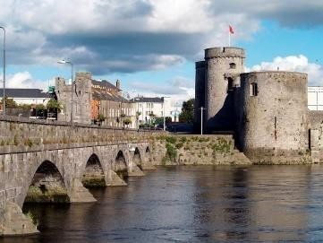
If you have tables in the work then the text in the table should also be in 9pt, Times New Roman. Tables should also be numbered and the table name is written above the table, as shown in the example below.

Picture 1: Name of the picture (9pt) Table 1: Name of the table (9pt)

CONCLUSION (10pt, Bold)

Please while writing the paper, pay attention to the instructions of writing otherwise we will have to return the paper or the paper will not be included into the conference program.

LITERATURE (10pt, Bold) Note:
Kindly use the same header.

